**Bug Tracking System**

**Introduction**:

System offers the easiest way to file, track, and fix bugs. It is an open-source bug tracking system that lets you test any application for the bugs Bugs can effortlessly be produced based on individual templates identity, prioritize, and allocate bugs to a particular person. Also, the dynamic bug lists give a detailed summary anytime. It does clean and grouping based on your requirements to generate detailed bug reports for stakeholders.

Additionally, Bug Tracking System final year project integrates your full project administration by activating Gantt charts or task Management or prioritize the bugs in the Scrum and Apple backlogs

Best and Trending Bug Tracking System Academic Project enables controlled software testing and bug tracking Comprehensive views on statu activities, and priorities give optimal support for decision making Besides, modified workflows based on thorough roles and permissions permit the most significant tracking and visibility Bug Tracking System Premium Projects also empowers QA executives and testers by providing added information regarding the incidence, method, or time of the bugs.

The primary purpose behind the Bug Tracking System free project source code and database is to track bugs and give a statement about them to the developer and project manager. It supplies the bug information with a unique id in the database for future reference. So, the project makes the job of managing the bugs easier

**Proposed method**:

1.identifying the bugs in the industrial application

2.No bug will remain unfixed in the developed system Not only identifying the bugs but also giving the bug information

3.As soon as the bugs are recognized. They are reported to the developer and point manager. To make sure that who need be specified before it is reported

This Bug Tracking System Project is perfect as your final item as it is easy to develop and use.

WORK DONE AND RESULTS:

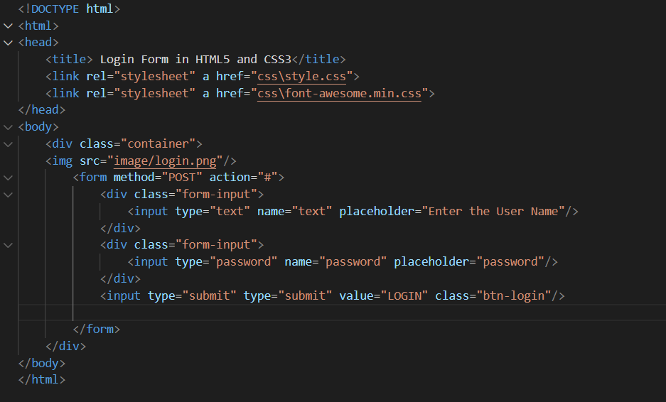

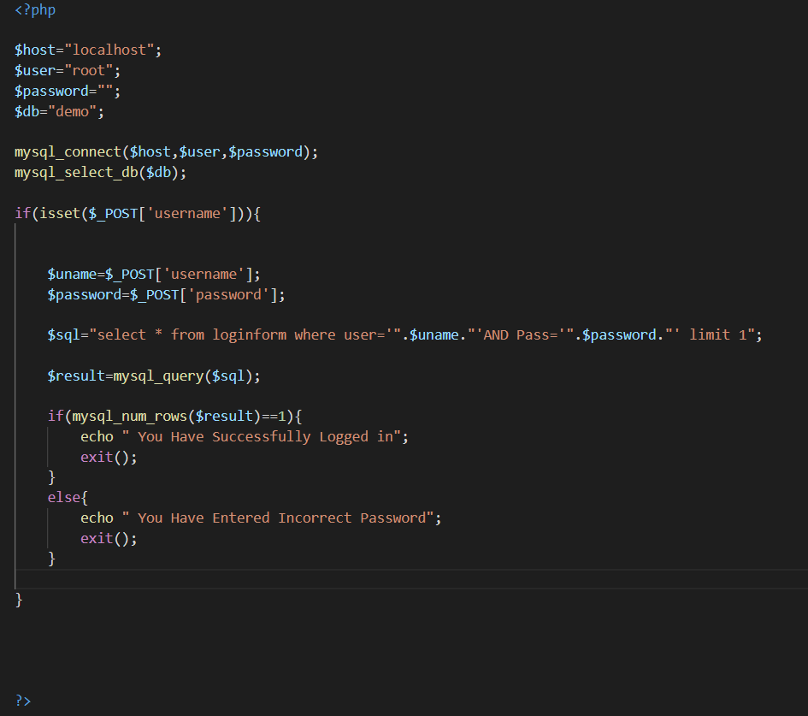

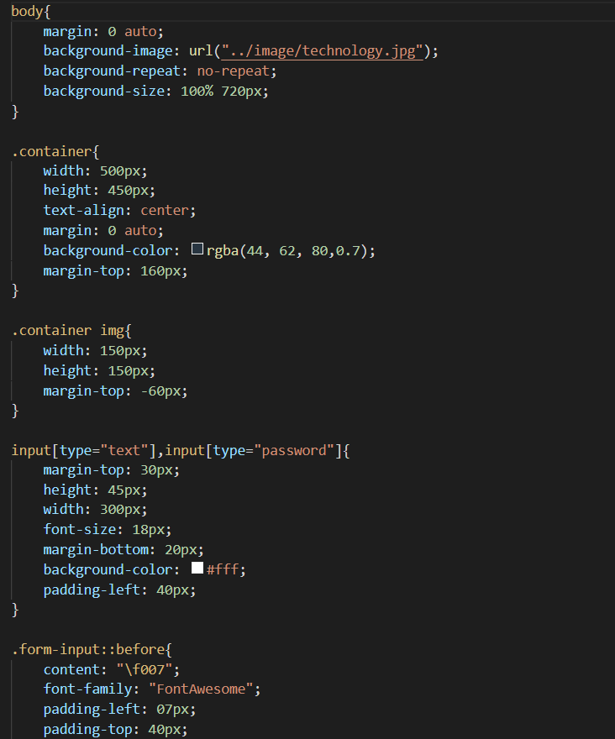

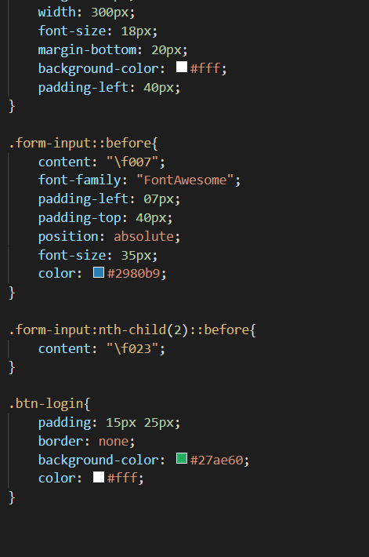

RESULTS:

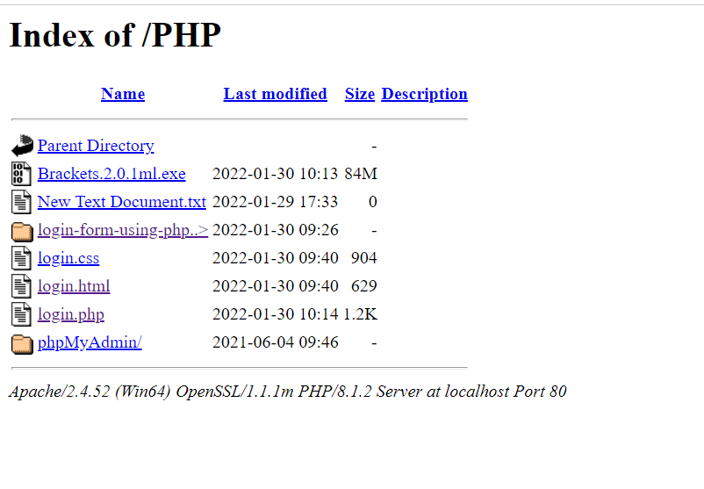

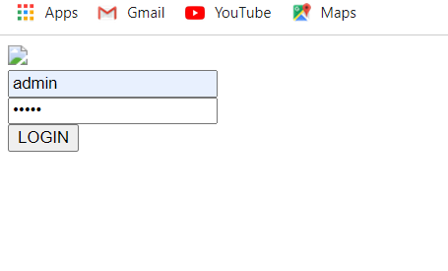

TECH STACK USED:

1.XAMPP

2.VS CODE : SQL,HTML,CSS

CONCLUSION:

THUS IN THIS WAY BUG GETS TRACKED AND CLEARED DYNAMICALLY AS ALL THE BUGS GET FIXED AND READY TO RUN.